**Section 3: Tableau**

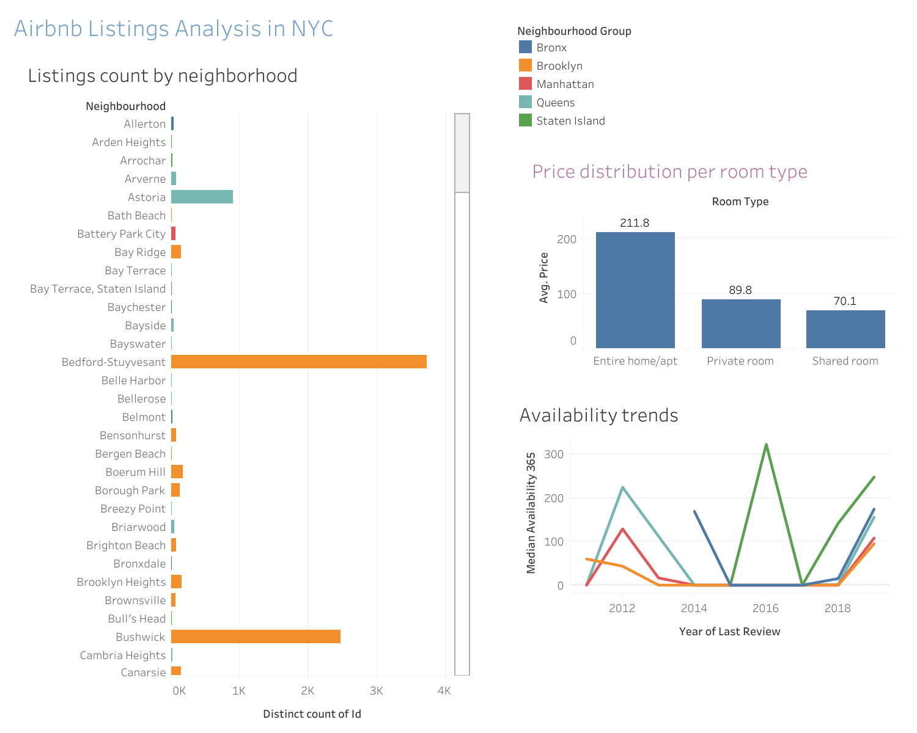



Views link:

<https://dub01.online.tableau.com/#/site/ranjinynk-435c02daba/workbooks/2507116/views>

Dashboard link:

https://dub01.online.tableau.com/#/site/ranjinynk-435c02daba/views/Cuvette_Task3/AirbnbListingsAnalysisinNYC?:iid=2

https://dub01.online.tableau.com/#/site/ranjinynk-435c02daba/views/Cuvette_Task3/AirbnbListingsAnalysisinNYC?:iid=2